Porting guide from K2 to K4

1. Basic Setting

**Step 1**:

Delete IVRSDK Folder from your K2 project:

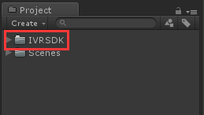

**Step 2**:

Git Clone K4 SDK from Github site:

<https://github.com/IDEALENSGroup/IVRSDK_Unity.git>

**Step 3**:

For K2 project, delete IVRCamera and EventSystem components, remove IVRRaycaster script form Canvas.

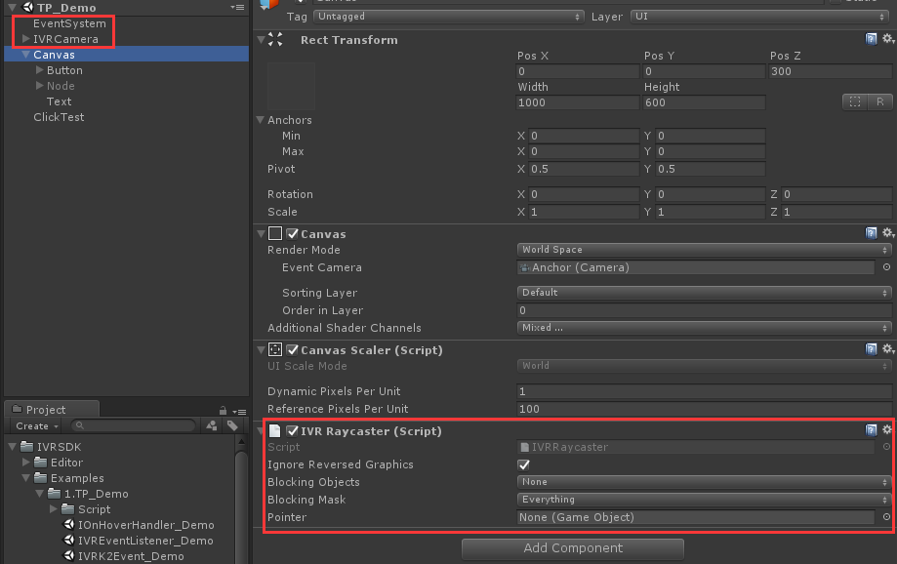

**Step4**:

Drag IVRManager and IVRInputModuleManager prefabs into the hierarchy.



**Step5**:

Add IVRGraphicRayster script to you own Canvas

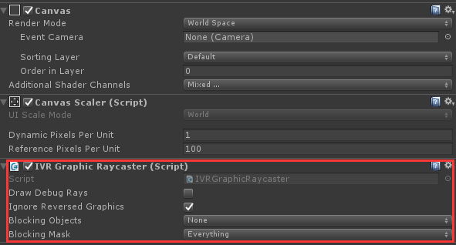

**Step6:**

If you got some compile errors, please see PART.3, it may help you.

Notice:

In K2 SDK, Red part of IVRCamera has been removed:

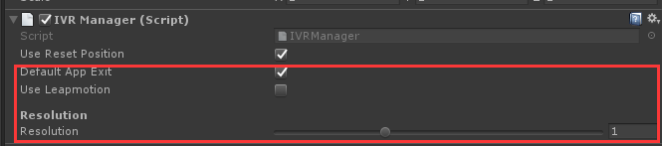

In K4 SDK,”Recenter Tracking” is same as “Use Reset Position” in K2 SDK.

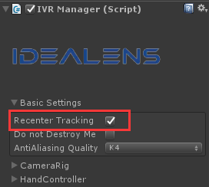

1. Project Setting

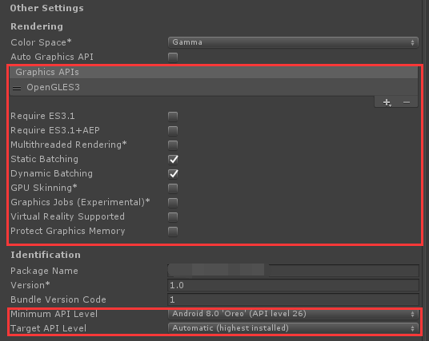

1. Compile Errors

Here are some errors when porting from K2 to K4 you may get. If you have any other error not mentioned here, you can submit issues on github. Before doing this, I recommend you to read development guide first.

**Error 1:**



Solve: Deletein your script, and replace by.

**Error 2:**



Solve: Please use *IVRInput.GetDown (IVRInput.RawButton.Back)*

Or, *IVRTouchPad.ButtonEvent_OnBackPress += OnBack;*

**Error 3:**



Solve: Please use *IVRTouchPad.TouchEvent_OnLongPress*

Notice: You may mention some methods from IVRToupad are missing. Just because the name of some interfaces has changed to make them more standardize. Please read development document and you will get right calls.

**Error 4:**



Solve: check 

**Error 5:**

Misssing IVRInputHandler.GetKeyDown , you can change to

*IVRTouchPad.TouchEvent_OnPressDown += OnPressDown;*

Misssing IVRInputHandler.GetKeyUp , you can change to

*IVRTouchPad.TouchEvent_OnPressUp += OnPressUp;*

**Error 6:**

IVRManager.Instance.Show is obsolete,

Recommend using *IVRPlugin.ShowToast*